**India’s Employment Crisis**

**Team Members:**

Usha Bhanu Komaragiri ([ukomara@iu.edu](mailto:ukomara@iu.edu))

Vishwa Shrirame ([vshriram@iu.edu](mailto:vshriram@iu.edu))

Ajinkya Pahinkar ([ajspahi@iu.edu](mailto:ajspahi@iu.edu))

Ayush Sekhsaria ([asekhsar@iu.edu](mailto:asekhsar@iu.edu))

**Abstract:**

In this fast-paced, advancing world where innovation and execution are limitless, one could say there is a vast scope of skilled/unskilled employment in the present and in the future. The reality is that every country suffers from the problem of unemployment as there are fewer jobs than the number of applicants in every sector. In our data visualization project, we first focus on how this unemployment crisis has affected India and what factors are responsible for this crisis. Through data, we would like to address India’s unemployment rate over the years and relate it with the scenarios leading to the same. We would consider factors like literacy, GDP per capita of the state, external factors like Covid-19, etc that have contributed to this increase and also discuss what possible measures can be taken to decrease this alarming rate in the future. Using data-driven analysis and visualizations, we aim to derive meaning from these datasets and address this ongoing problem.

**Introduction:**

Unemployment is an alarming problem all over the world. The problem has aggravated in recent times and the economic slowdown is taking up many jobs with the majority of the leading companies having declared a hiring freeze. Many capable youths are not able to put their skills to the best use while there are tons of hourly wage people who are losing their jobs. This is happening all over the world, and it is only visible when conditions become severe. As we mentioned above, unemployment is a serious problem and so after looking at India’s state-wide data, we aim to bring to notice how serious the problem is and correlate it with the factors which caused them to happen in the first place

Unemployment is one of the major socio-economic problems in India. The number of unemployed divided by the total number of people in the civilian labor force is the unemployment rate. Not everyone who is jobless is unemployed. In order to be included in the unemployment rate, a person must not only be jobless but also have actively sought employment over the previous four weeks. A person is still included even if they were just temporarily fired and are waiting to be called back to their position. In the unemployment rate, people are not included if they have given up seeking work.

Structural unemployment: Unemployment occurs when an educated individual is unable to find employment. Despite having the qualifications, this unemployment is caused by the absence of work prospects in the Indian economy. In the Indian economy, structural unemployment is also known as educated unemployment. Educated unemployment is a growing issue in the country. Particularly during the pandemic, the country's educated unemployment has undergone a paradigm shift.

**Motivation:**

The consequences of unemployment are an intriguing reason to study this. One of the most crucial measures of a nation’s health is its ability to offer individuals who want jobs, a place to work. As a result, the unemployment rate which reflects the inability to create such employment becomes the most crucial sign of how well a modern economy is doing.

The well-being of society increases with the proportion of the labor force that is productively engaged in a population. A society where the majority of people are employed offers relief from vulnerability and poverty. Households are also motivated to spend more to enhance their quality of life. Households promote economic expansion and more employment in this way.

On the other side, a rise in unemployment weakens overall consumer spending, slows the economy, and most significantly, makes people more vulnerable to changes in the economy. Using the data and with the help of visualizations we can identify which regions are most affected by unemployment, thus it is important that such indicators are available so that correct actions can be taken in a timely manner. Our main motivation is to enlighten these factors and represent our results using various visualization techniques.

**Existing visualizations:**

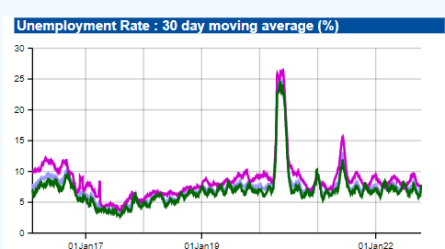

*Fig 1: 30-day moving average of unemployment rate in India*

The daily and monthly unemployment rates in India, in rural India, in urban India, as well as for the Indian states, are provided by CMIE. Every day, a 30-day moving average of the unemployment rate in India is calculated by the CMIE using the data gathered over the previous 30 days. According to the May-August 2022 report from the Center for Monitoring Indian Economy (CMIE), the nation's unemployment rate rose to 8.3% in August of that year. This rate is the highest it has been in the previous year. More than 20 lakh individuals lost their jobs in August 2022. In Figure 1 we can see a huge spike around the year 2020 in the unemployment rate which tells us the effect of Covid-19 on industries. An observation could be that the X-axis labels are not defined in a detailed manner as I had to estimate the spike to be around the year 2020.

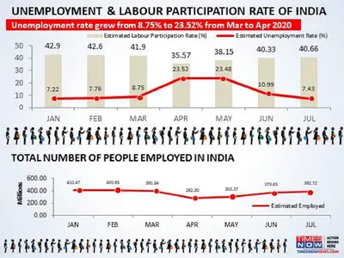

*Fig 2: Unemployment and Labour participation rate in 2020*

In figure 2 we see a visualization posted by Times Now that depicts how the Covid-19 outbreak has affected the unemployment rate in India. The rate grew from 8.75% to 23.52% from March to April 2020 which is very shocking. So many people lost their jobs in that period which led to this increase but the rate soon came back to normal in 3 months' time which explains the lockdown period. However, there are certain things that seem unnecessary in this visualization. From the first graph, we understand that unemployment has gone through a huge change but the below graph is just an opposite way of expressing the first graph. And the images in between also seem unnecessary which depicts a cluttered visualization as a whole.

**Questions & Objectives:**

Some of the questions we would like to answer from our visualizations are:-

1. How has covid-19 affected the unemployment rate in India?
2. Which states do we observe a high/low unemployment and employment rate? What could be the factors?
3. Is education an important factor that affects the unemployment of the state?
4. Does the GDP per Capita affect the unemployment rate of that particular state?
5. How’s labor participation spread in India? Is it more in rural areas or urban areas?
6. What's the ratio between the population of adults and the employment rates of a particular region?

We hope to provide clean visualizations that answer these questions in a holistic manner.

**Dataset and methods:**

We have identified multiple datasets that can help us in our implementation. We will focus on state-wise statistics of unemployment, education, GDP, and thus some data cleaning would be required to join the data.

Some of the important columns that we will use are :

* State [*Categorical*]
* Date [*Date-Time*]
* Unemployment Rate (%) [*Continuous*]
* Employment Rate (%) [*Continuous*]
* Labour Participation Rate (%) [*Continuous*]
* Population [*Continuous*]
* Sex-ratio [*Continuous*]
* Net state domestic product (NSDP) [*Continuous*]
* Literacy rate etc. [*Continuous*]

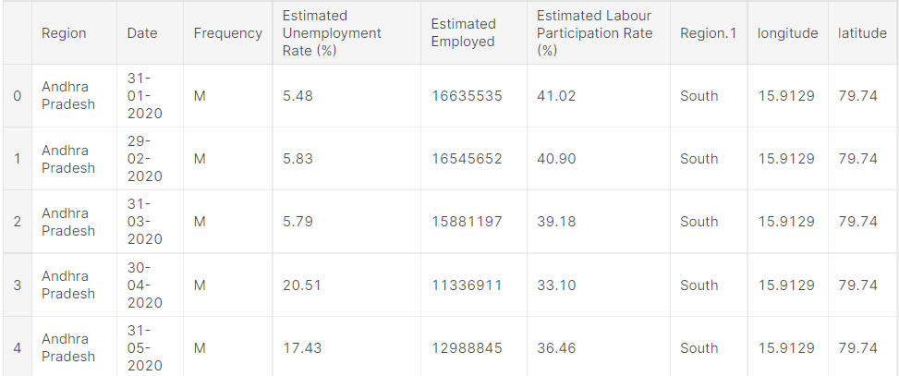

*Table 1: Region-wise unemployment dataset*

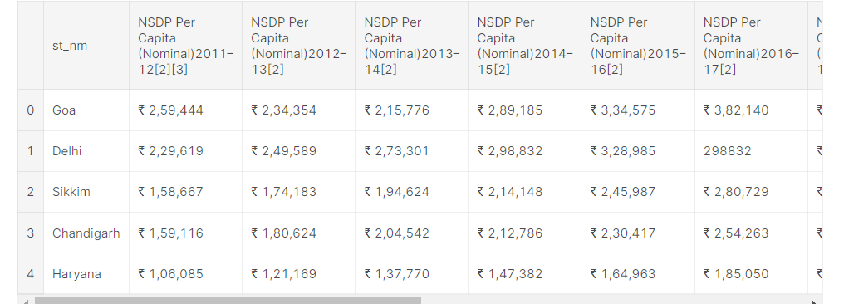

*Table 2: GDP per capita of states on a yearly basis*

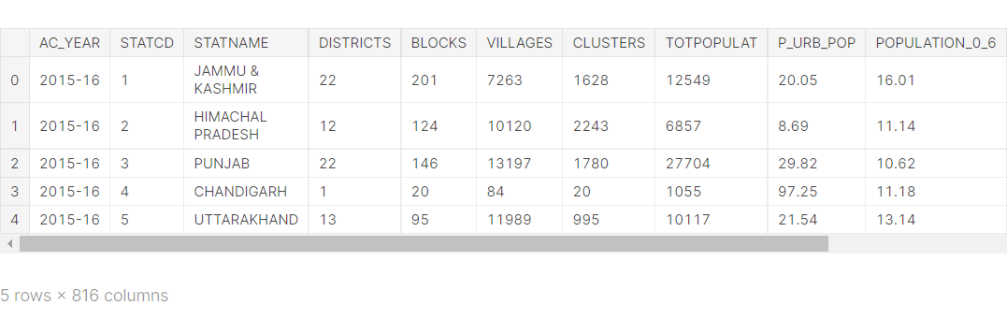

*Table 3: District and state-wise education data on a yearly basis*

**Methods**:

An initial approach would be, to begin with, the map showing the unemployment rate highlighted with colors according to severity. Some graphs that show the trend for various states that would depict the underlying data seen on the map. After that, for the rise in unemployment, we would like to consider GDP data, male to female work power ratio, and literacy rate to delve deeper into the factors. We would like to compare several states in India with the employment rate for various age gaps of people as this would address the linkage between age and unemployment rate and take into consideration the literacy rate. We hope to include more factors as we go ahead with the implementation of our project.

**References:**

1. <https://www.kaggle.com/datasets/gokulrajkmv/unemployment-in-india?select=Unemployment_Rate_upto_11_2020.csv>
2. <https://www.kaggle.com/datasets/rajanand/education-in-india>
3. <https://www.kaggle.com/datasets/varunnagpalspyz/india-statewise-gdp-per-capita-geometry>
4. <https://www.kaggle.com/datasets/mukeshmanral/income-data>
5. <https://unemploymentinindia.cmie.com/>
6. <http://udise.in/src.htm>
7. <https://www.timesnownews.com/business-economy/economy/article/how-the-covid-19-outbreak-has-affected-the-joblessness-rate-in-india-explained-in-4-charts/634284>